## Front End Engineering-II

Project Report

Semester-IV (Batch-2022)

**EduWeb**



**Supervised By: Submitted By:**

Faculty Name : Miss Sonia Malik Name :Priya , Prerna Sharma

Roll No :2210992095,2210992086

**Department of Computer Science and Engineering**

**Chitkara University Institute of Engineering & Technology,**

## Chitkara University, Punjab

**Introduction to EduWeb: Empowering Education through Online**

**Welcome to Eduweb**

**At Eduweb, we believe in the transformative power of education and technology. Our mission is to bridge the gap between traditional learning methods and the digital providing a comprehensive platform that enhances educational experiences for students, educators, and institutions alike.**

EduWeb is a cutting-edge educational website designed to transform traditional learning into dynamic online experiences. With its suite of comprehensive features and user-friendly interface, EduWeb revolutionizes education management, providing a centralized platform for administrators, teachers, students, and parents to interact seamlessly in the digital space.

**Eduweb is a pioneering educational technology company dedicated to creating innovative and accessible learning solutions. Our team consists of passionate educators, tech enthusiasts, and creative designers who work together to develop tools that foster engaging and effective learning environments.**

EduWeb is not just a website; it's a transformative tool that empowers educational institutions to thrive in the digital age, providing flexibility, accessibility, and innovation in education delivery.

**What We Offer**

**Eduweb offers a wide array of services and resources designed to support diverse learning needs:**

**Interactive Courses: Engaging and interactive courses across various subjects, tailored to different age groups and learning styles.**

**Educator Resources: A rich library of teaching aids, lesson plans, and professional development materials to empower educators.**

**Student Tools: Interactive tools and resources to help students grasp complex concepts and excel in their studies.Institutional Support: Comprehensive solutions for educational institutions to enhance their digital infrastructure and streamline administrative processes.**

**Objective :**

The objective of Eduweb is to revolutionize education by harnessing the power of online platforms. By leveraging technology, Eduweb aims to make quality education accessible to all, breaking down geographical barriers and providing learning opportunities to individuals regardless of their location or socioeconomic status. Through interactive and engaging online courses, Eduweb seeks to empower learners with knowledge and skills essential for personal and professional growth in today's rapidly evolving world.

**Key Features of Eduweb**

1. **Interactive Courses**: Engaging multimedia content and interactive exercises to enhance learning experiences.
2. **Personalized Learning Paths**: Customized curriculum and progress tracking tailored to individual learners' needs and pace.
3. **Flexibility**: Offering flexible scheduling and learning options, allowing students to balance their education with other commitments.
4. **Real-world Applications**: Integrating real-world examples, case studies, and practical exercises to apply theoretical knowledge in practical scenarios.
5. **Certification**: Offering certificates or badges upon successful completion of courses, providing recognition for acquired skills and knowledge.
6. **Community Support**: Building a supportive learning community where students can network, seek advice, and share experiences with fellow learners and alumni.
7. **Efficient Administration**: EduWeb streamlines administrative tasks, from student enrollment to scheduling classes, enabling institutions to operate smoothly in the online realm.
8. **Enhanced Communication**: Through its communication hub, EduWeb facilitates seamless interaction between all stakeholders, fostering collaboration and engagement.

Top of Form

**Problem Statement: Enhancing Education Management with EduWeb**

1. **Background**:

* Traditional education management systems often face challenges in adapting to the demands of modern education, particularly in the online realm.

1. **Challenges**:

* ***Limited Learning Resources***: Traditional methods of content delivery may not fully leverage digital resources, hindering the richness of the learning experience.
* ***Data Management Issues***: Inadequate systems for collecting, analyzing, and utilizing data limit institutions' ability to make data-driven decisions.
* ***Lack of Personalization***: One-size-fits-all approaches to education may not cater to the diverse needs and learning styles of students.
* ***Communication Barriers*:** Lack of centralized communication platforms leads to inefficiencies and misunderstandings among stakeholders.

**Hardware and Software Requirements for Developing an Education Website**

**Hardware Requirements:**

1. **Computer**: A desktop or laptop computer for web development.
2. **Operating System**: Windows, macOS, or Linux.
3. **Processor**: Modern processor (e.g., Intel Core i5 or AMD Ryzen).
4. **Memory (RAM)**: At least 8GB RAM recommended.
5. **Storage**: Adequate space for project files and development software.

**Software Requirements:**

1. **Text Editor or IDE**:
   * Text Editor: Sublime Text, Visual Studio Code, Atom, Notepad++, etc.
   * IDE: WebStorm, Visual Studio, IntelliJ IDEA, etc.
2. **Web Browser**:
   * Google Chrome, Mozilla Firefox, Safari, Microsoft Edge, etc.
3. **Version Control System** (optional but recommended):
   * Git, GitHub, GitLab, Bitbucket.
4. **Local Server** (optional for dynamic websites):
   * Apache, Nginx, XAMPP/WAMP/MAMP.
5. **Graphics Software** (optional):
   * Adobe Photoshop, Adobe Illustrator, GIMP, Sketch, etc.

**Programming Languages and Libraries:**

1. **HTML (Hypertext Markup Language)**:
   * Text editor or IDE for writing HTML code.
2. **CSS (Cascading Style Sheets)**:
   * Text editor or IDE for writing CSS code.
   * Optionally, preprocessors like Sass or LESS.
3. **JavaScript**:
   * Text editor or IDE for writing JavaScript code.
   * Optionally, JavaScript framework/library like React.js, AngularJS, or Vue.js.

**Internet Connection:**

* Stable internet connection for accessing online resources and documentation.

**Proposed Design:**

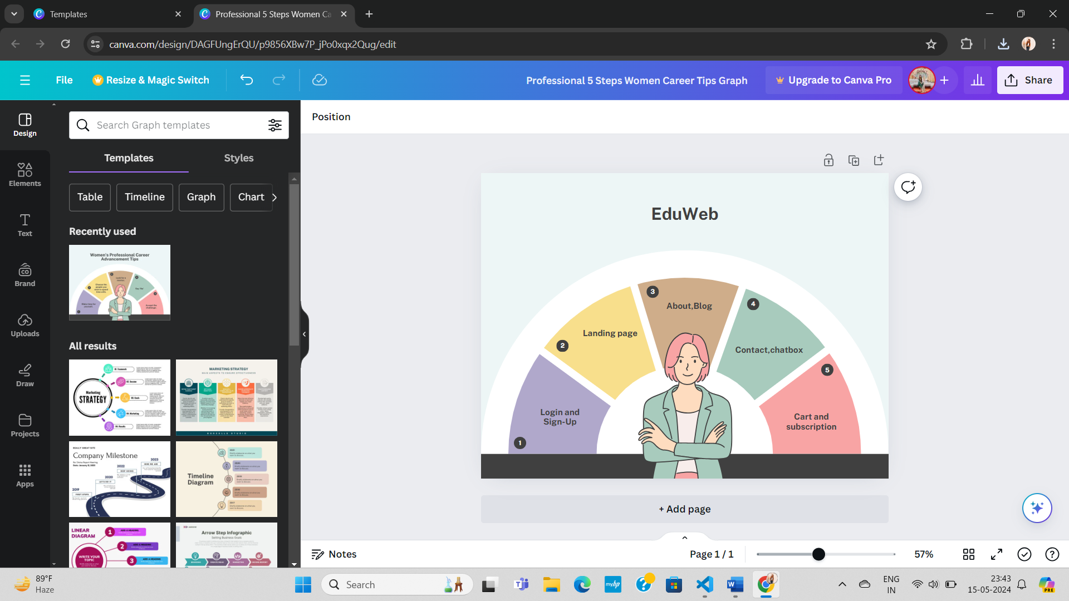

**Code Snippets:**

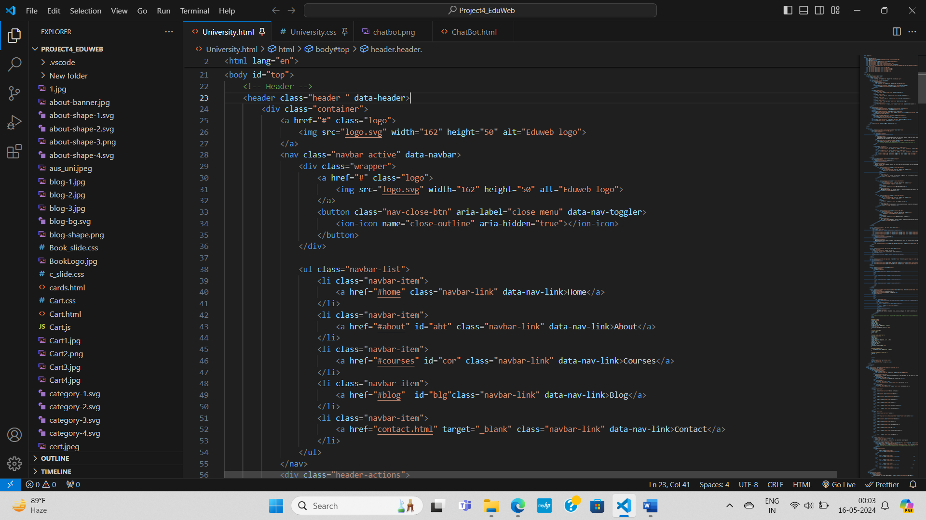

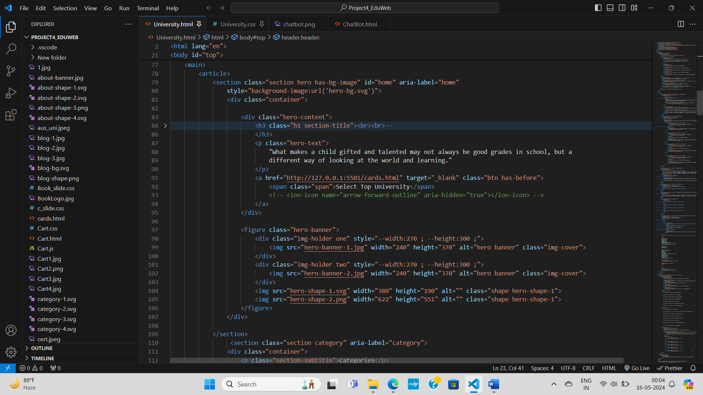

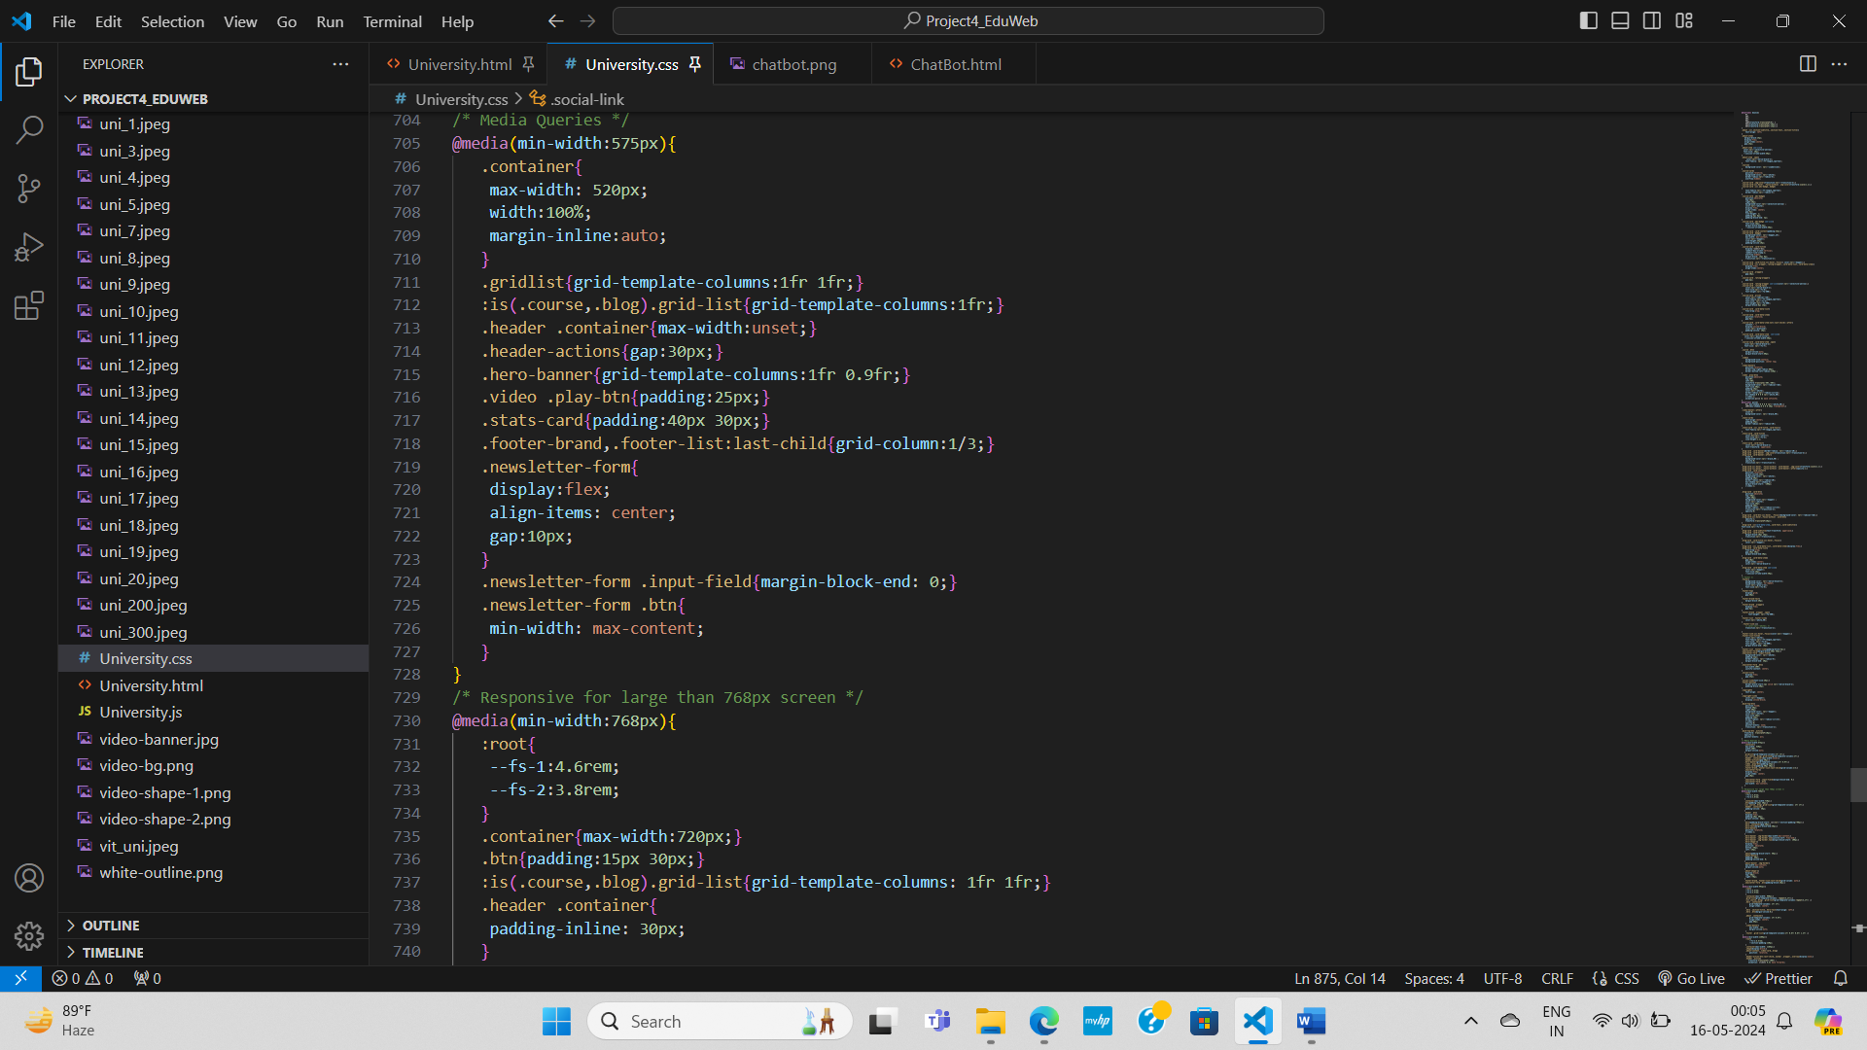

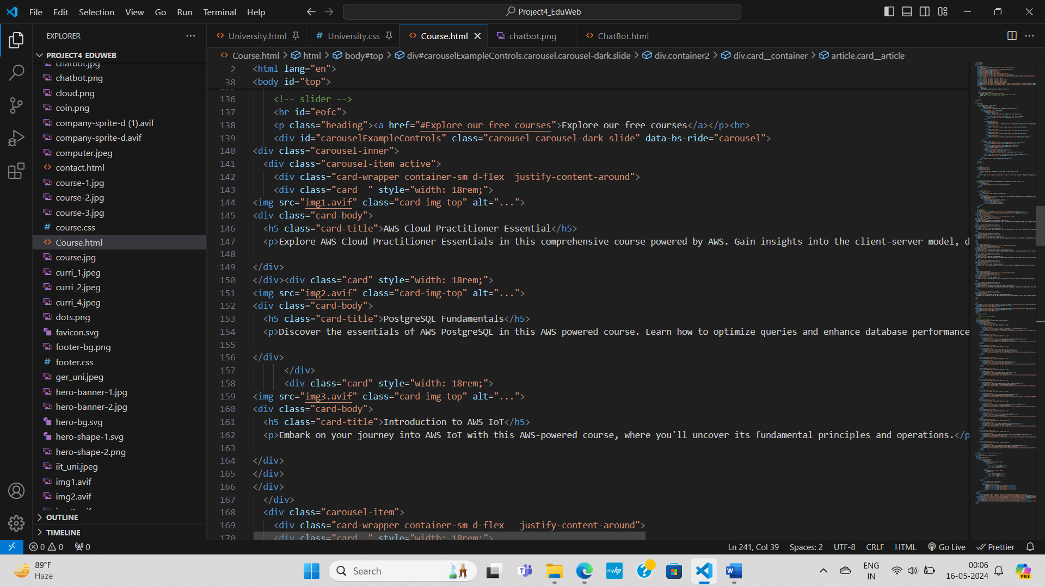

**Logo**

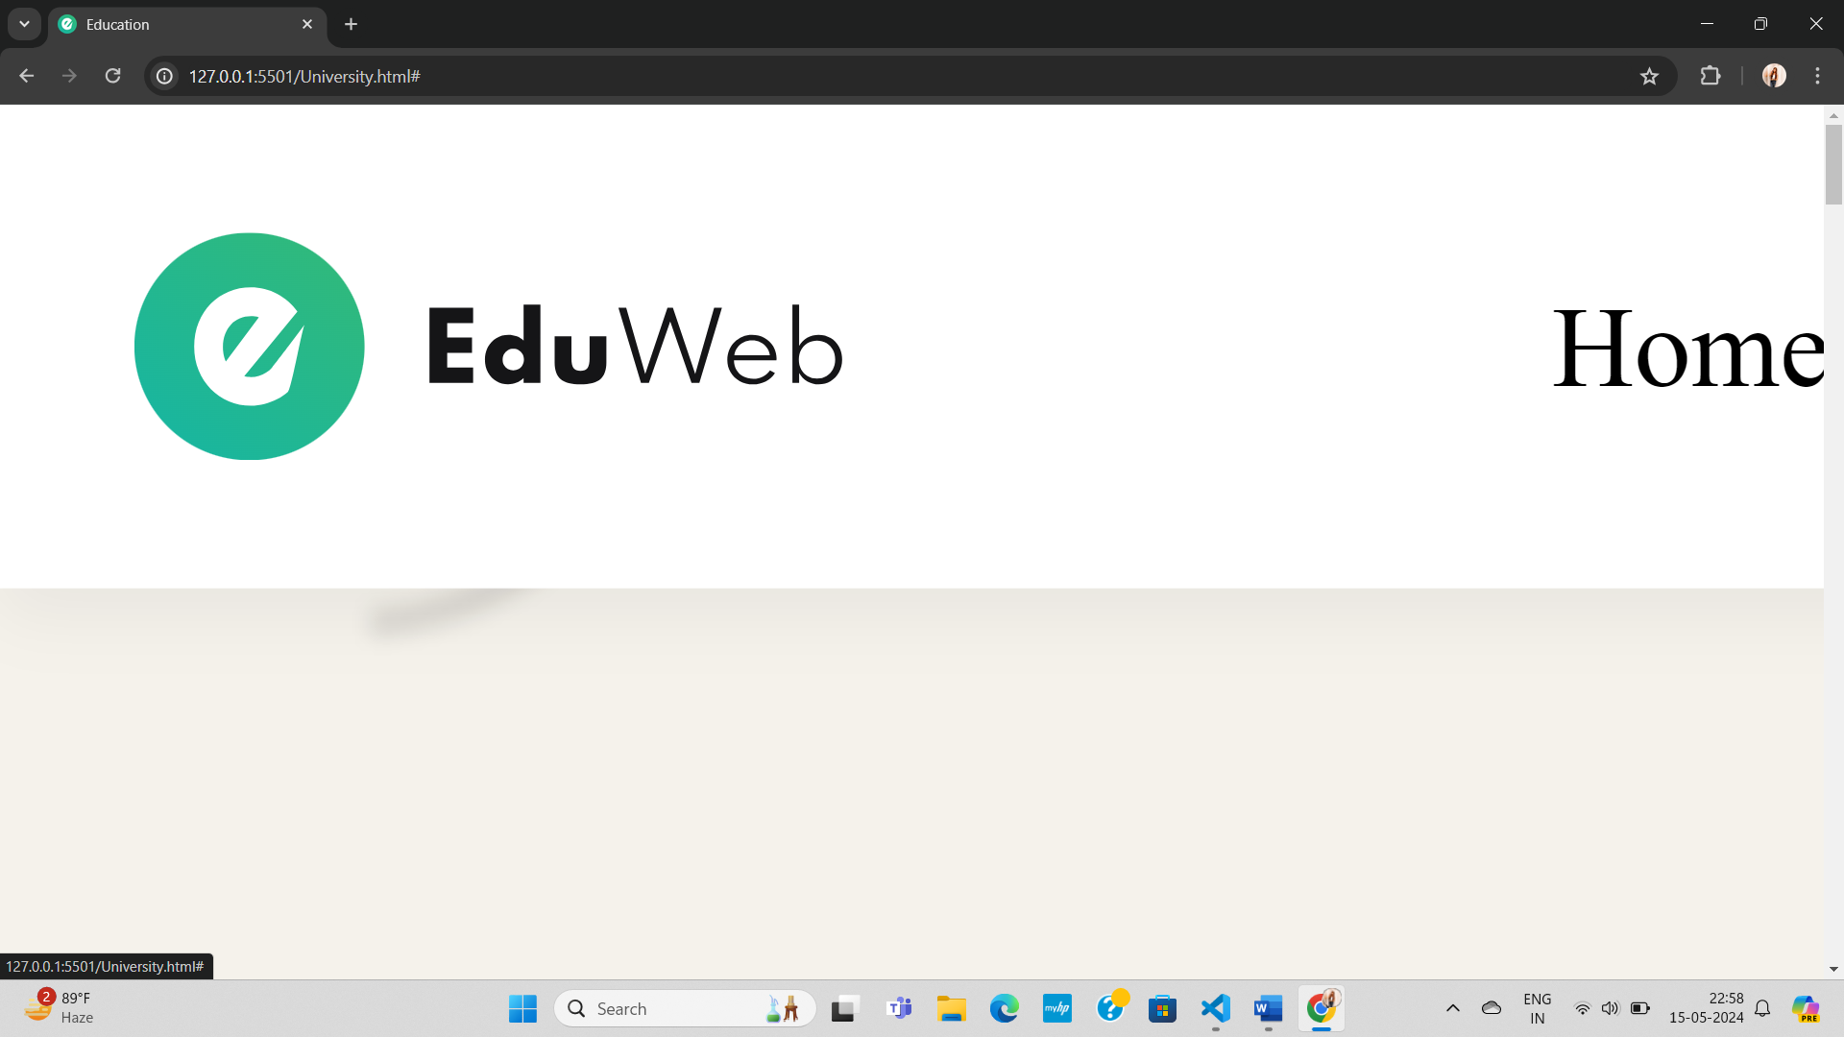

**Home**

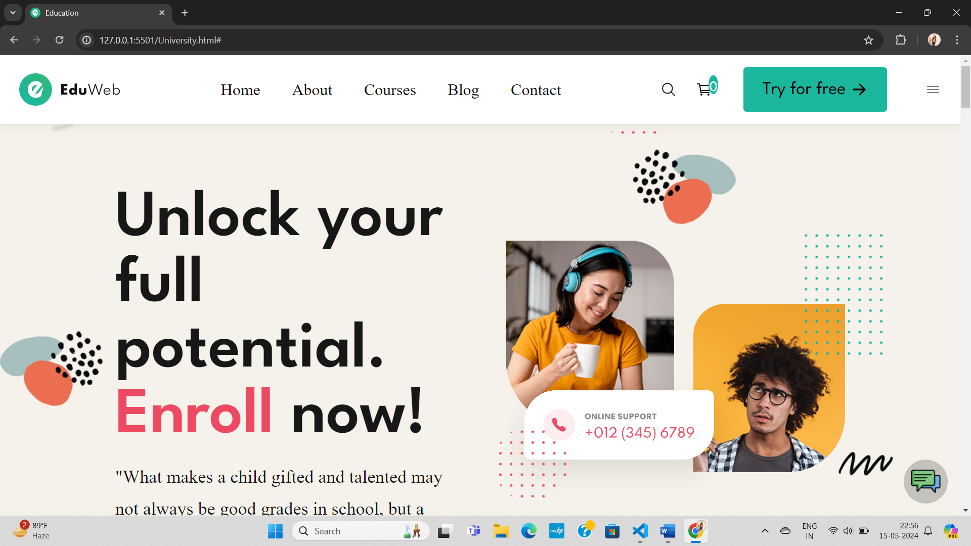

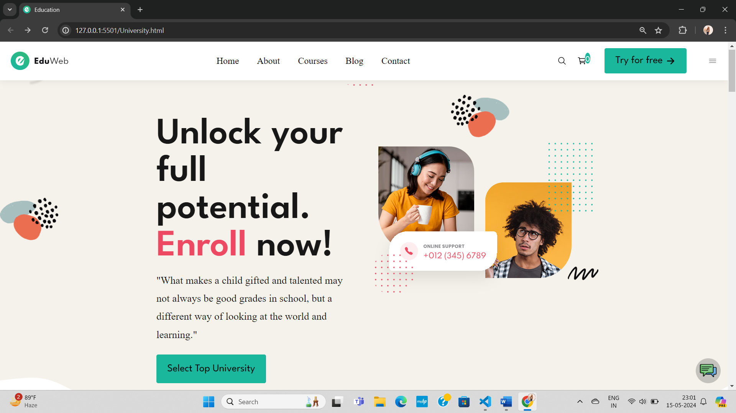

**Categories**

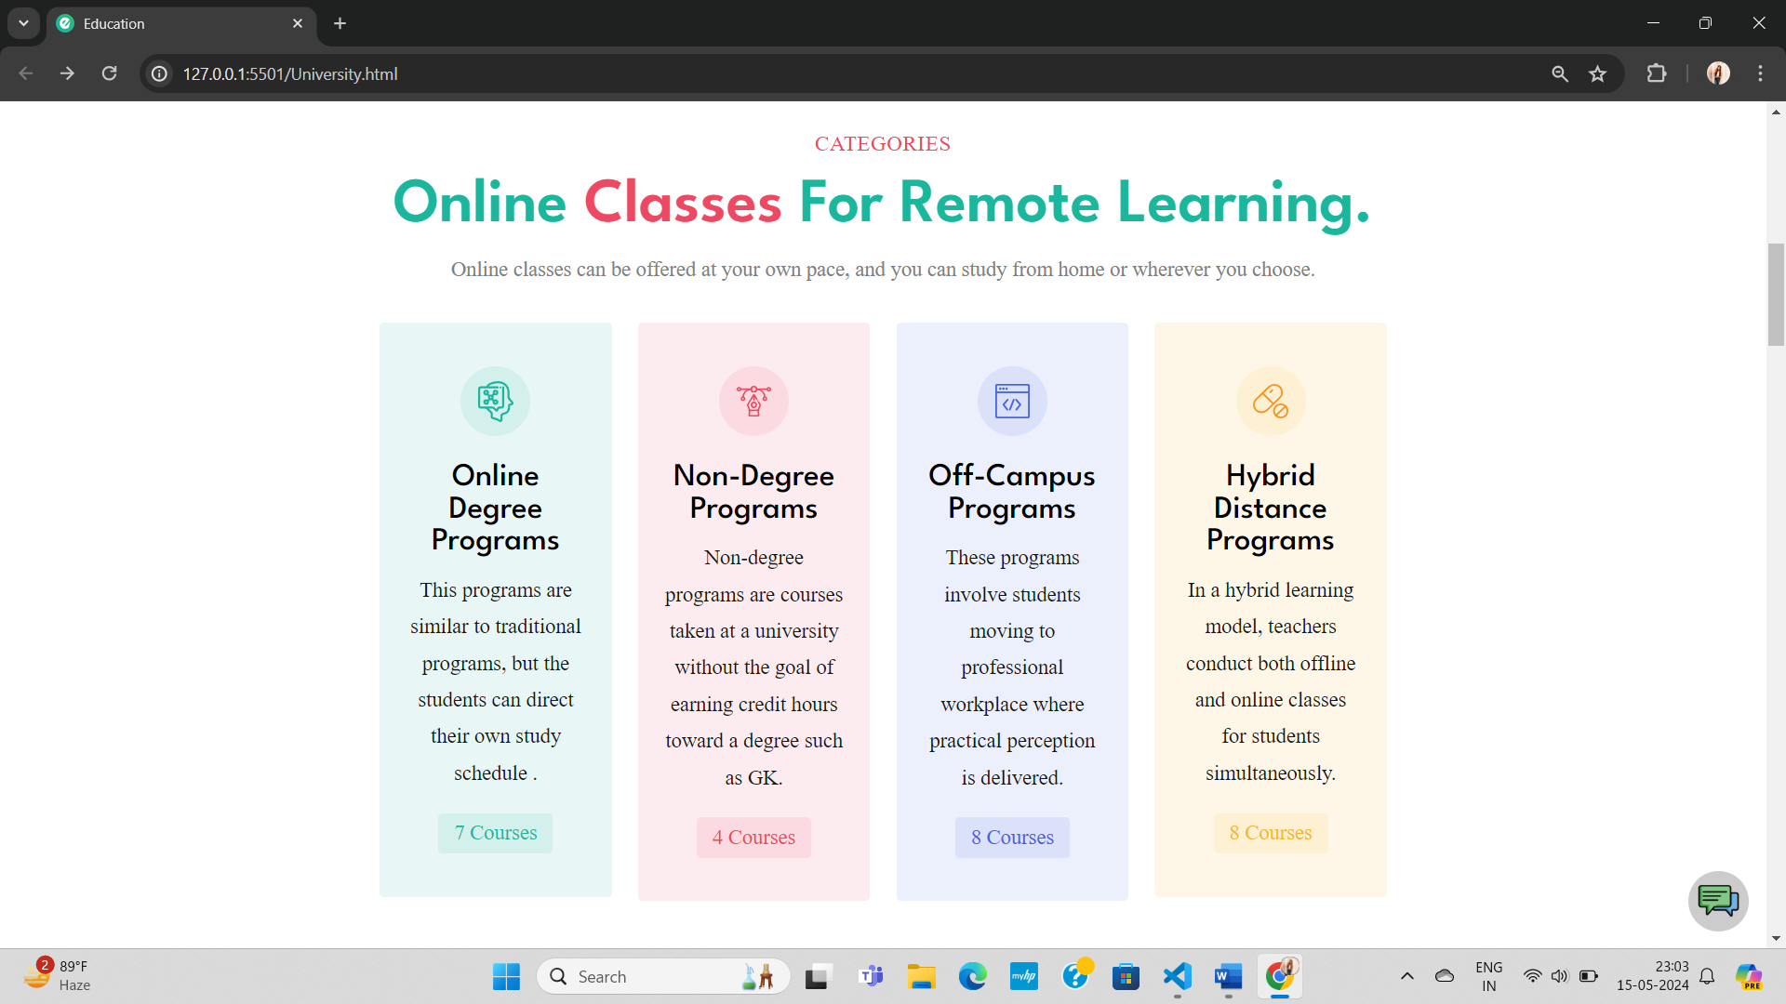

**About**

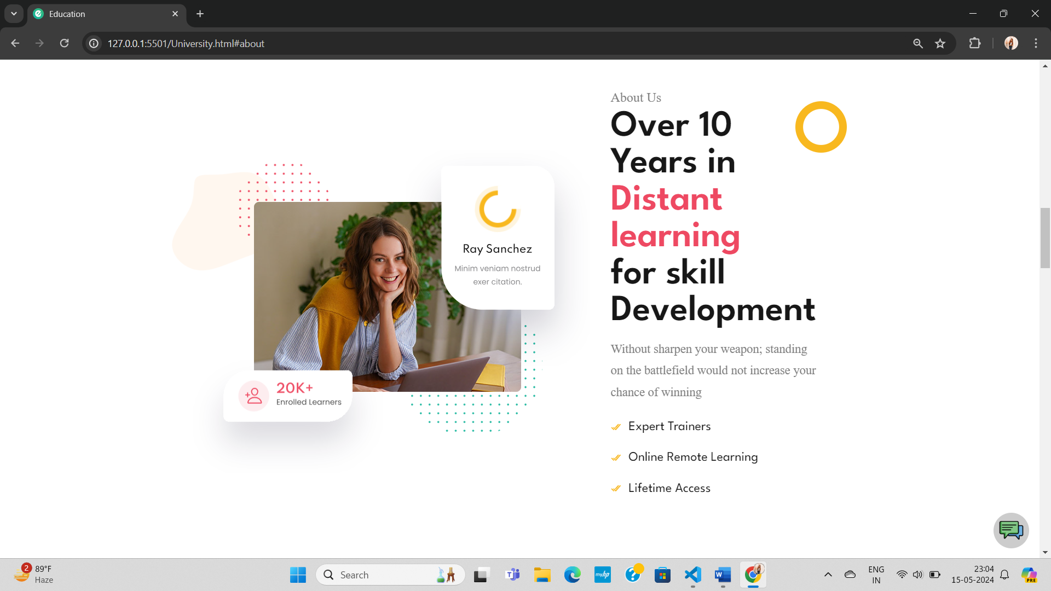

**Courses**

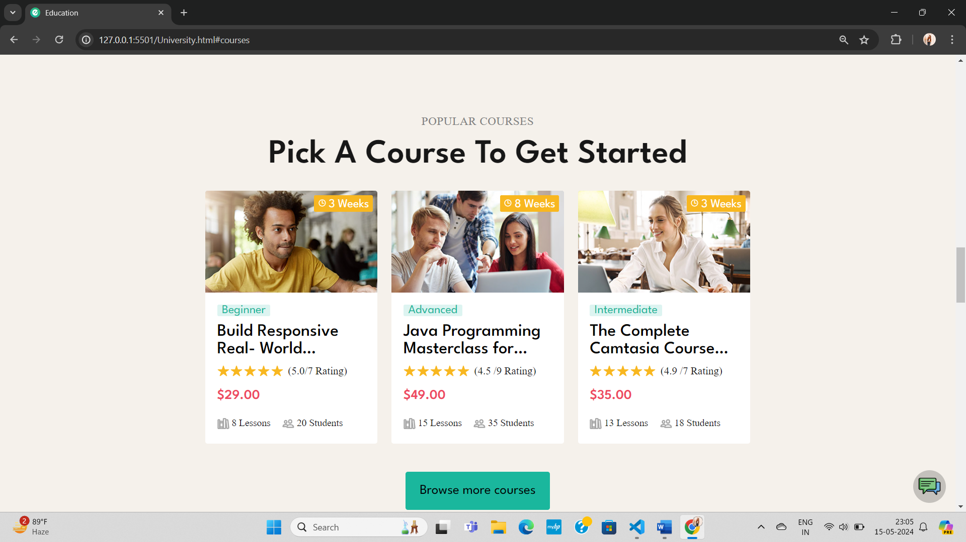

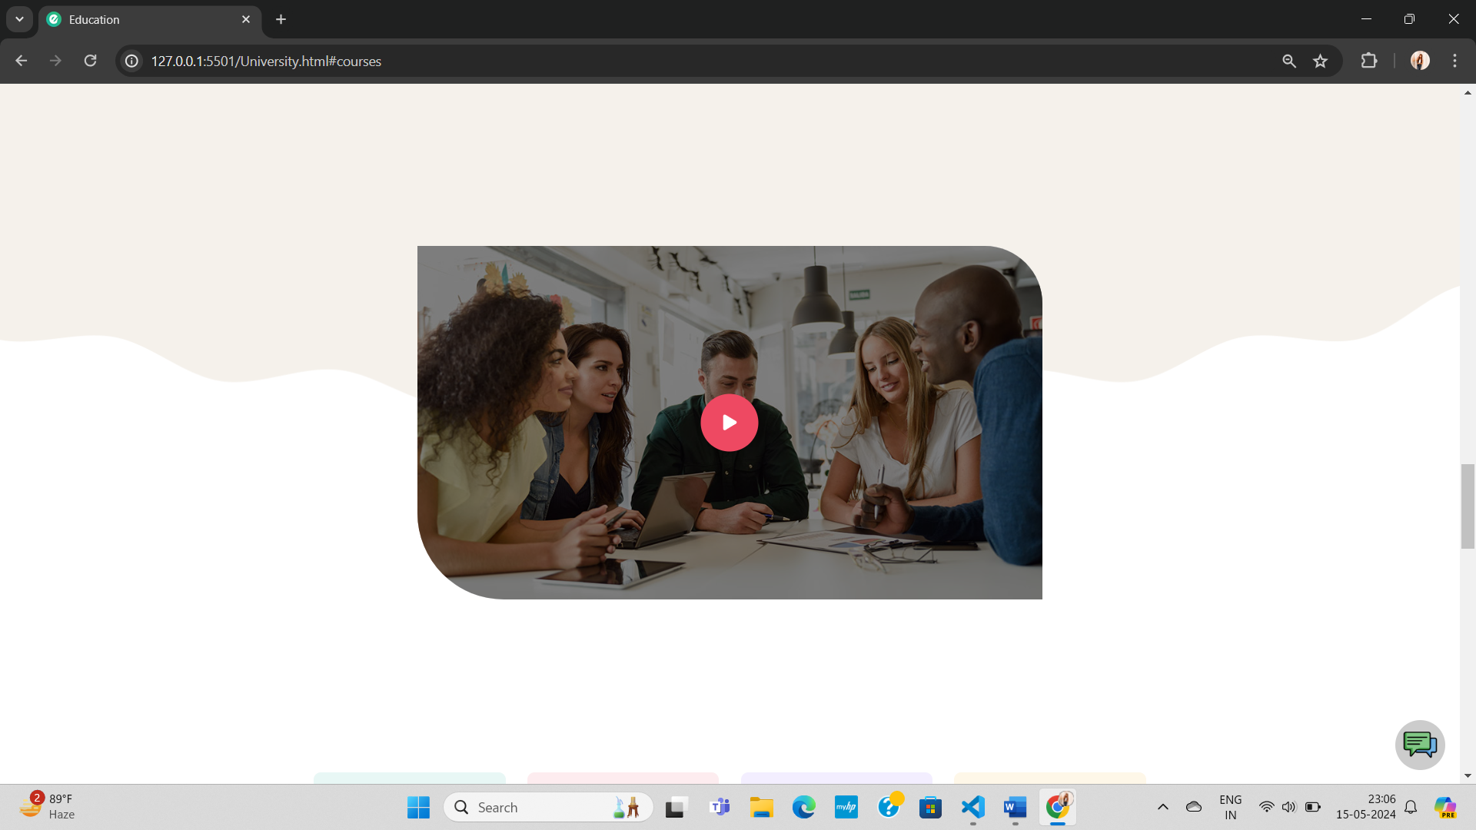

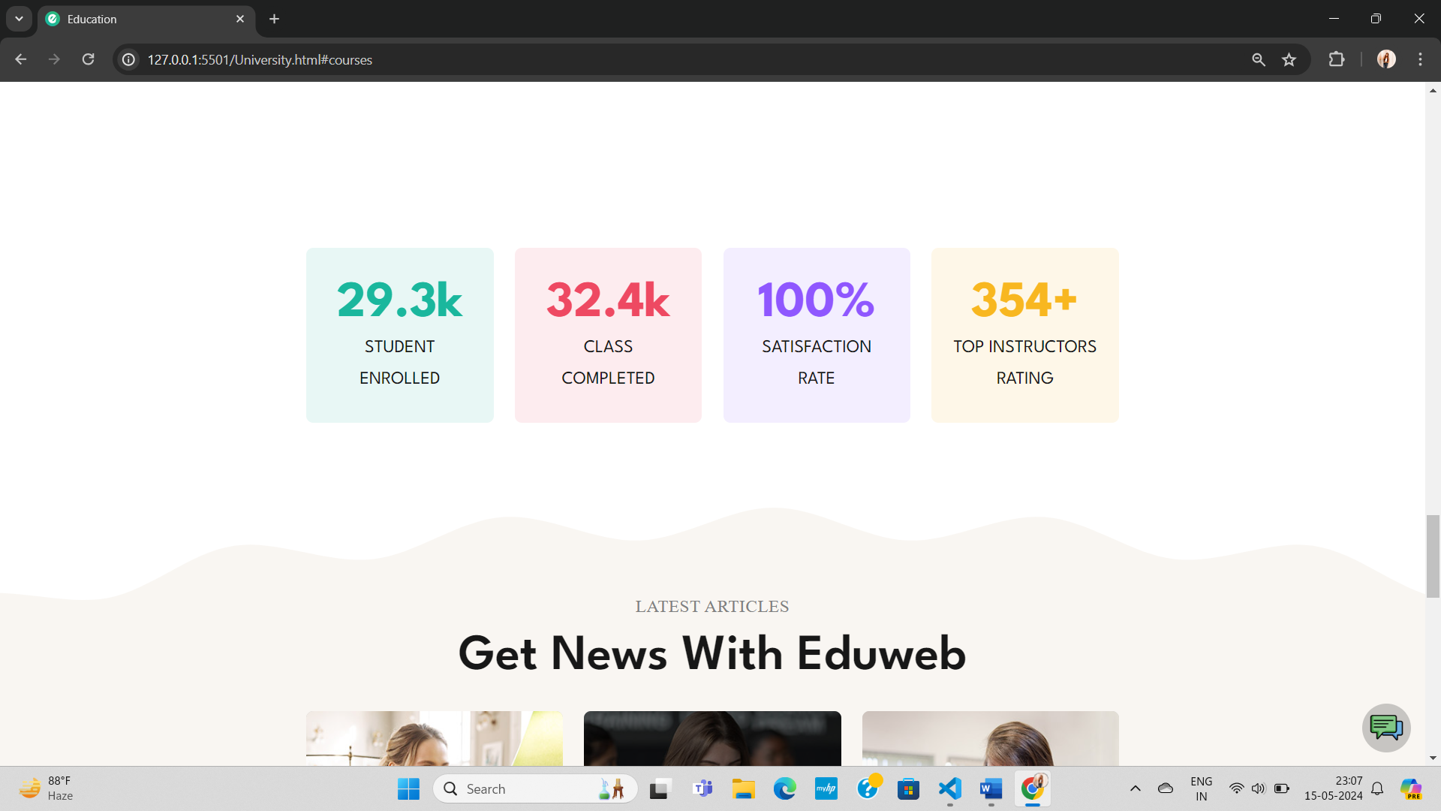

**Blog**



**Top University**

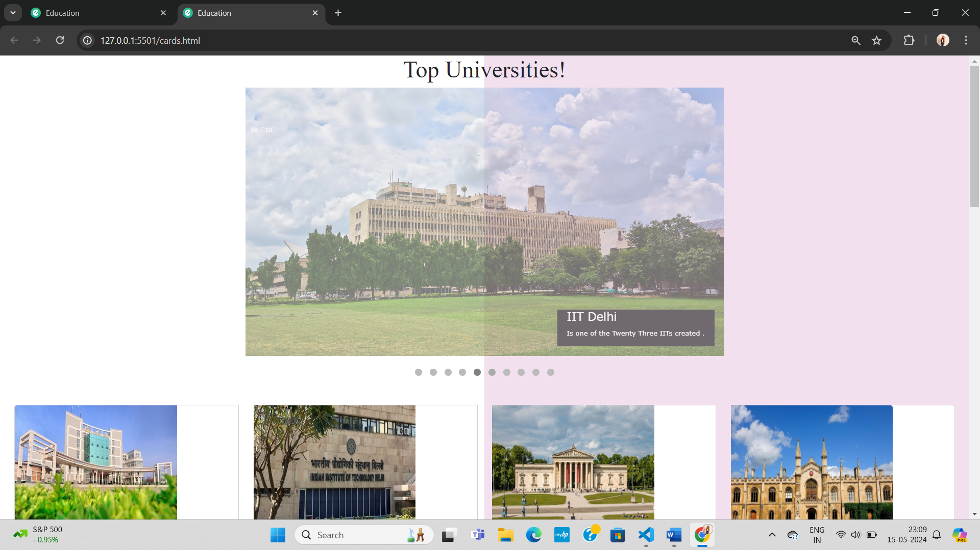

**Flip-Book**

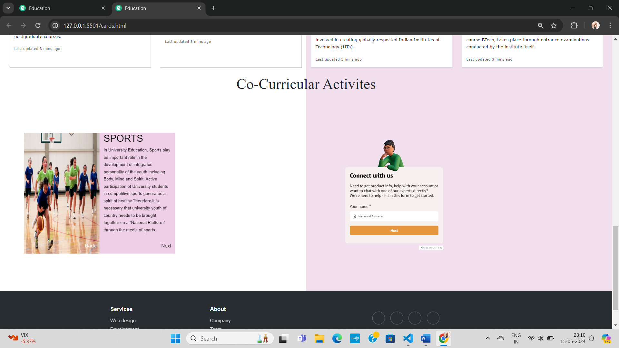

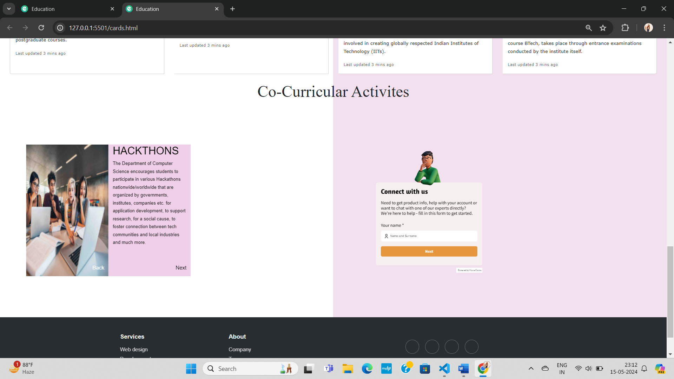

**Contact**

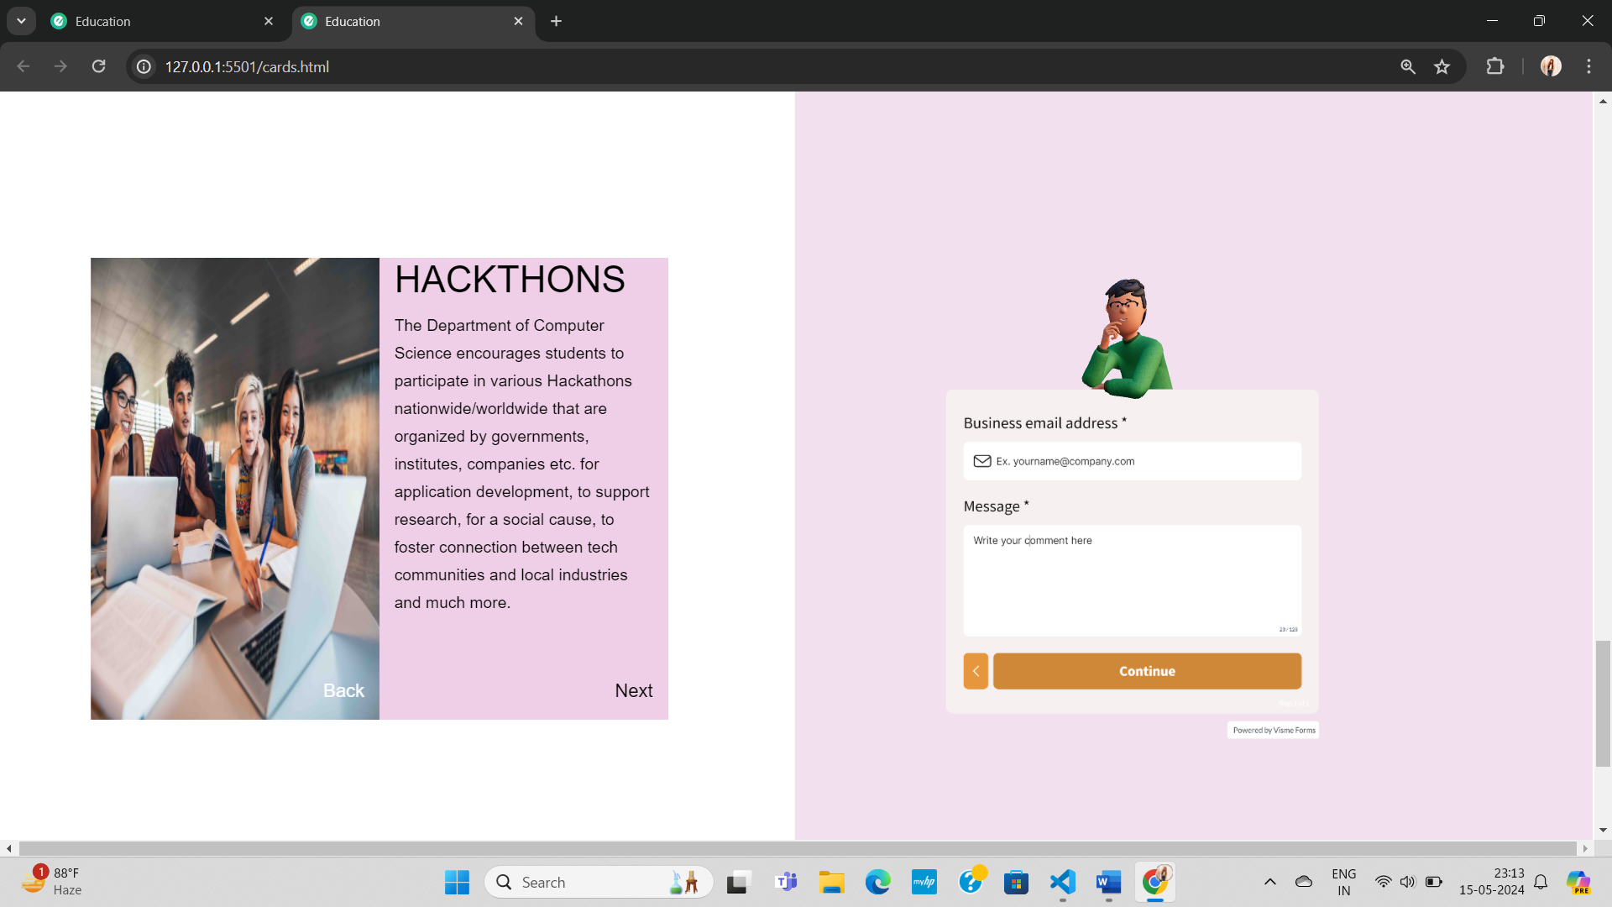

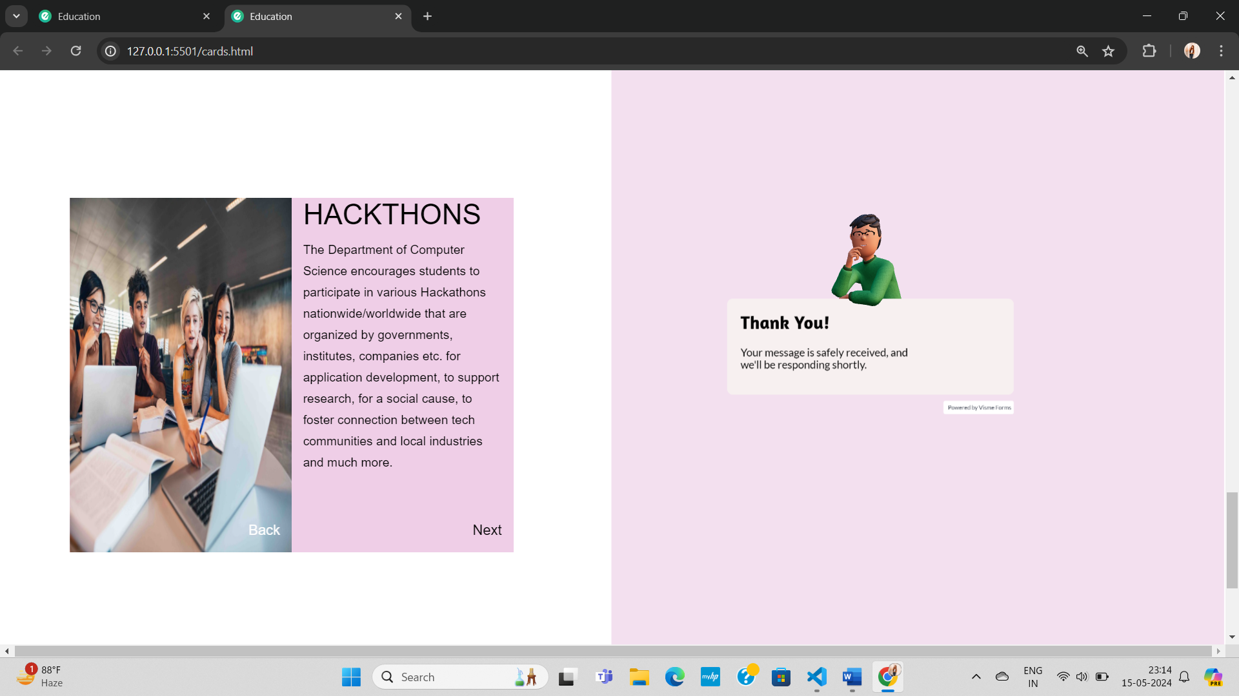

**Top University**

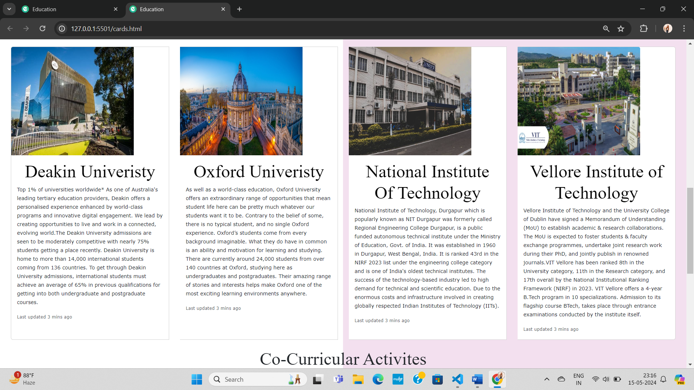

**Explore More Course**

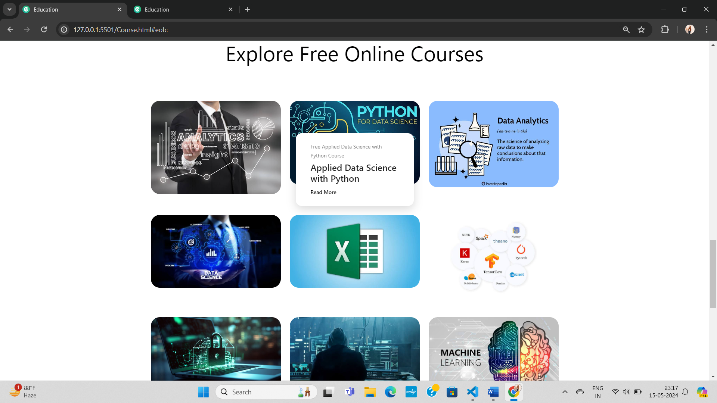

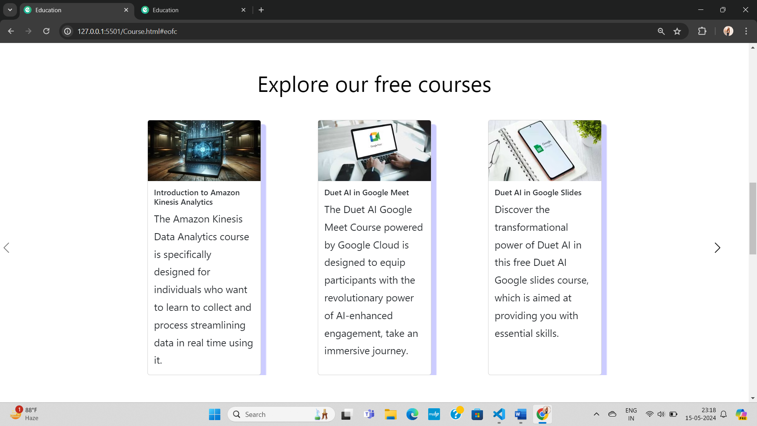

**Cart**

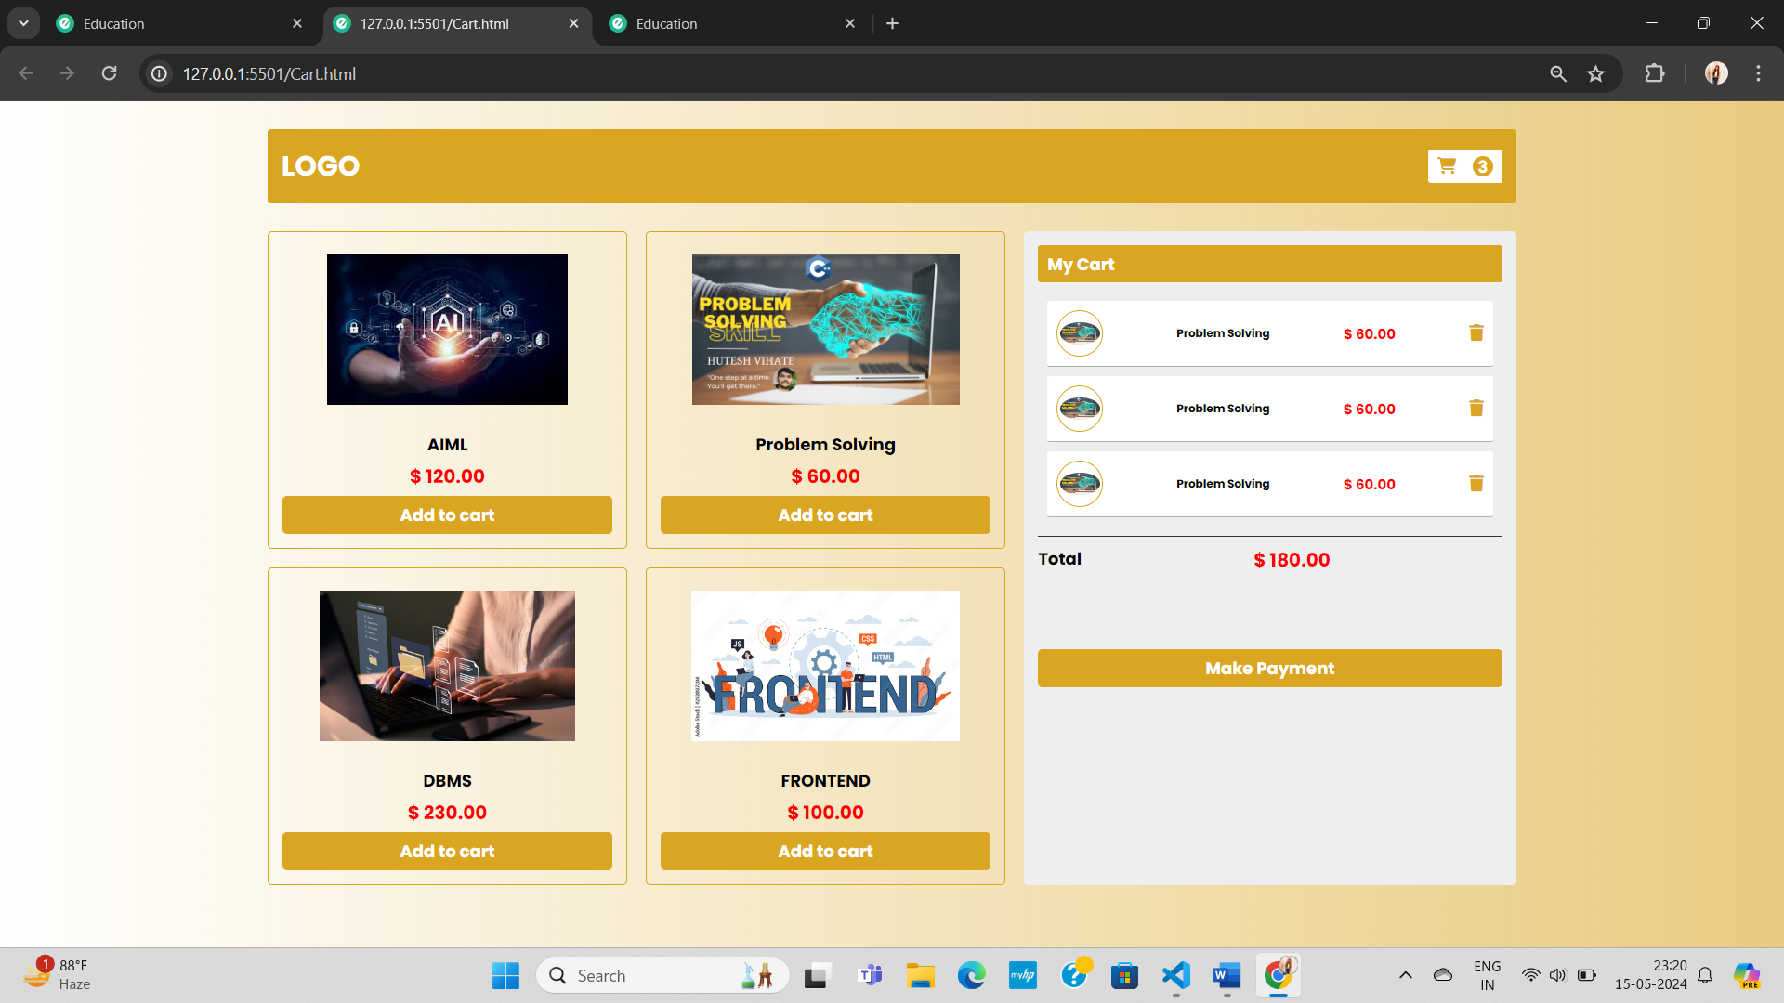

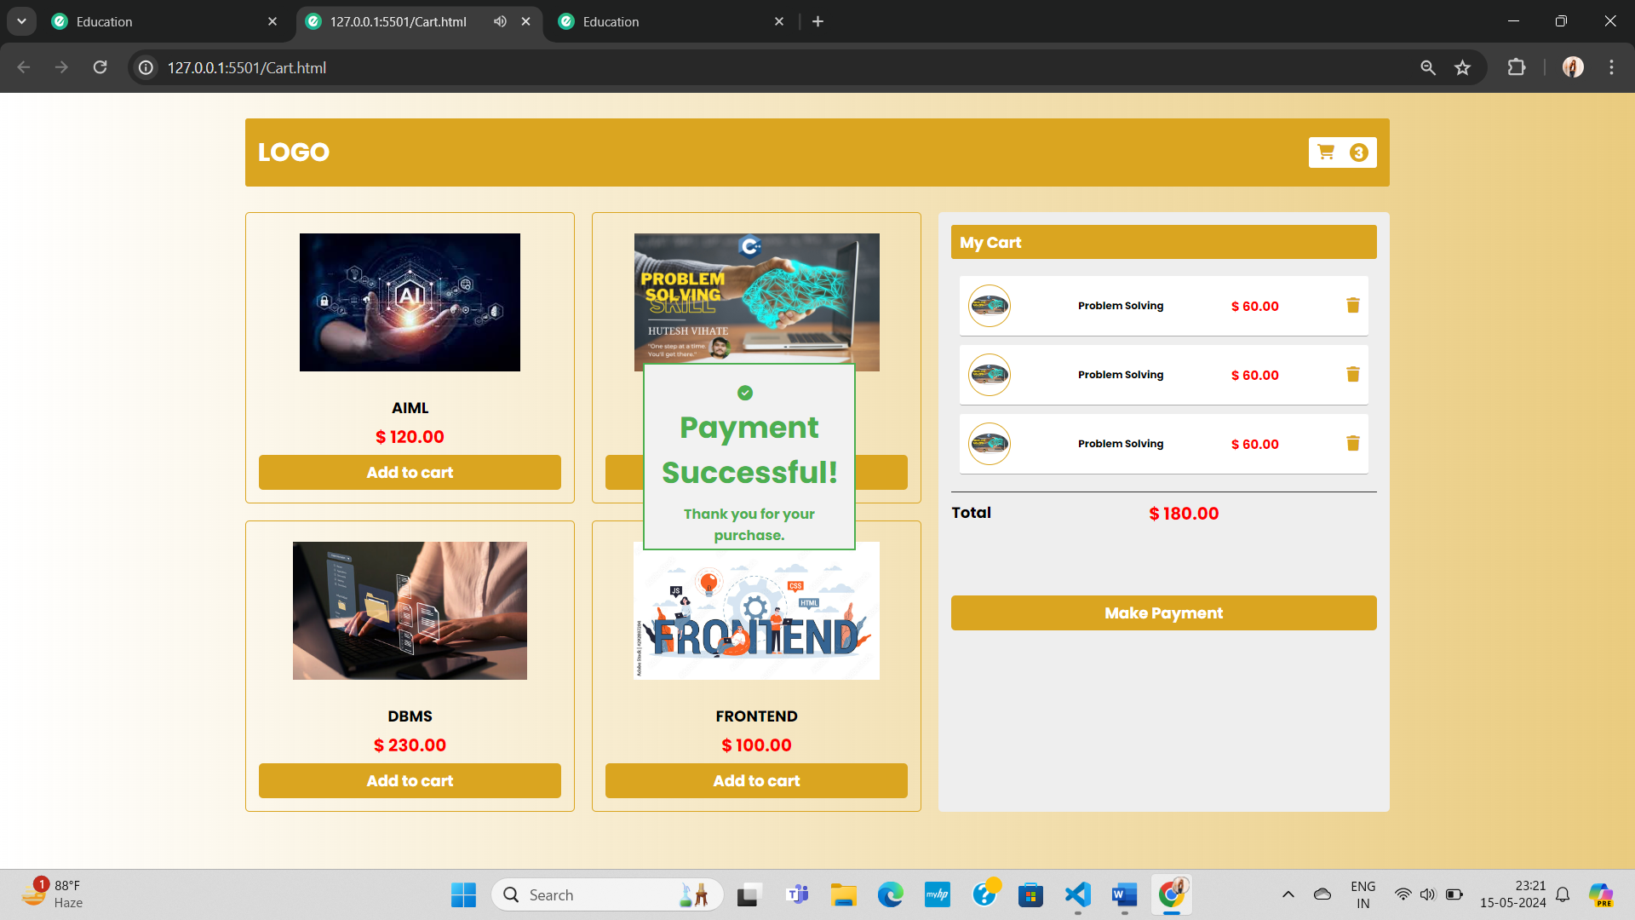

**Subscription:**

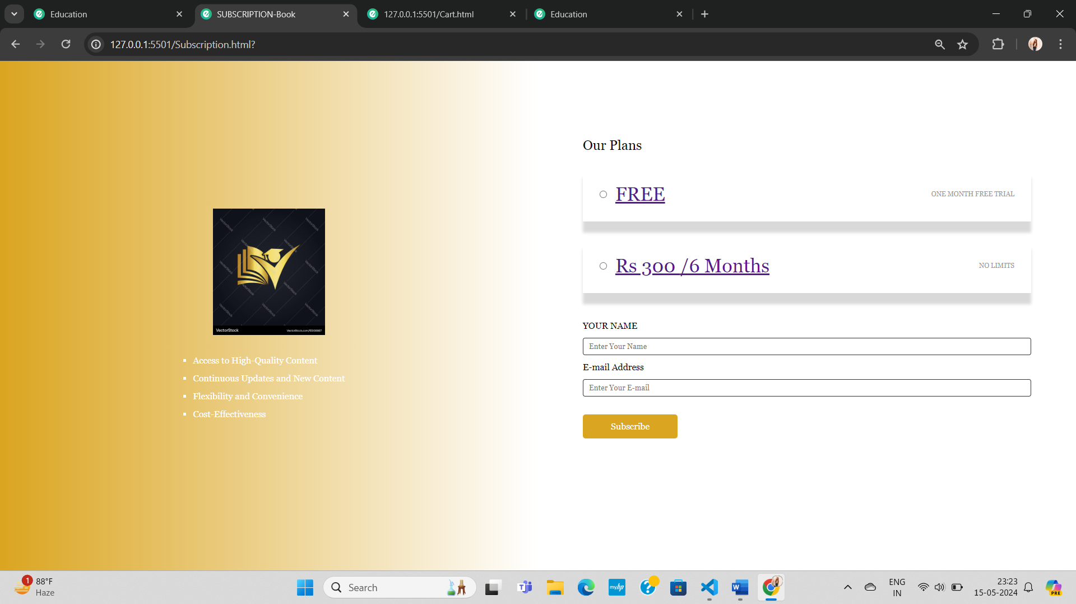

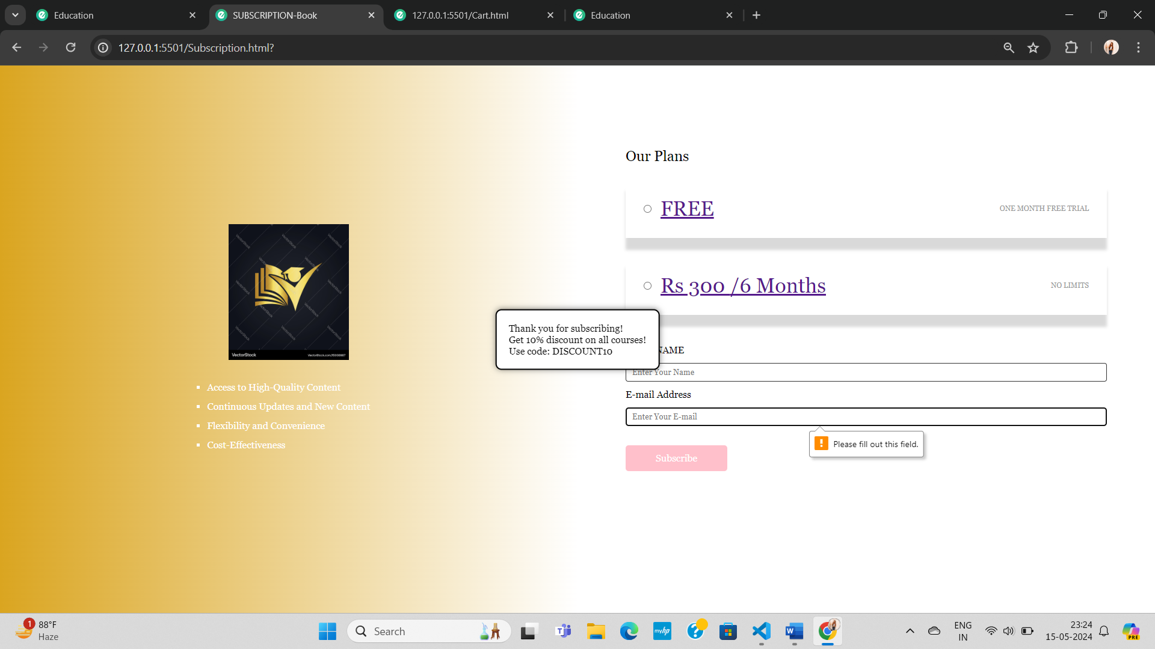

**Contact**

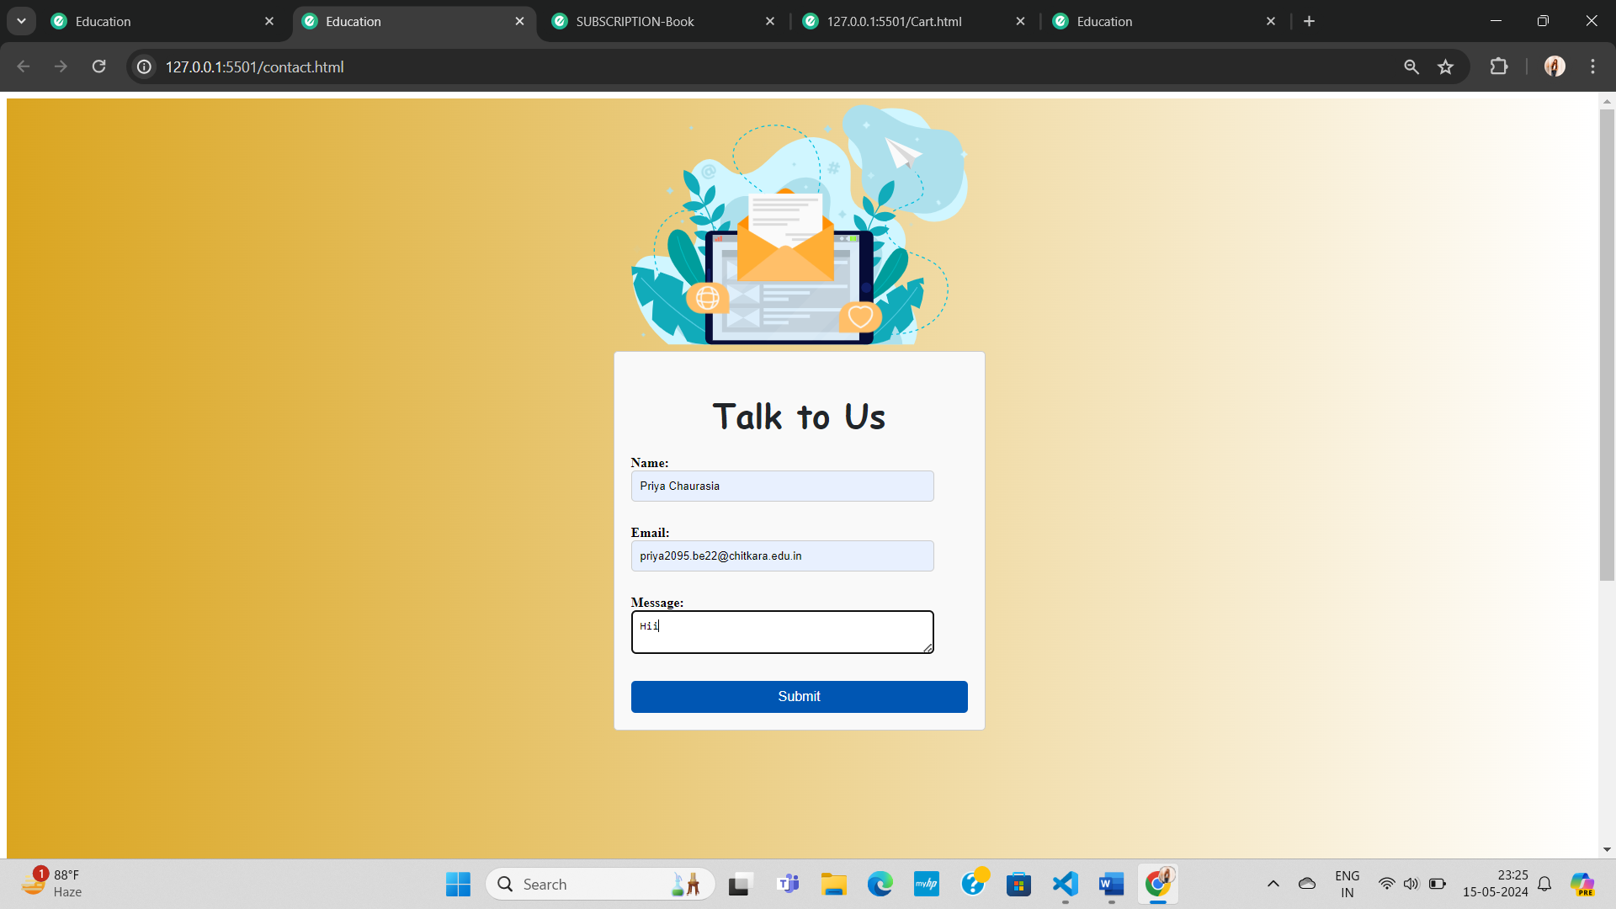

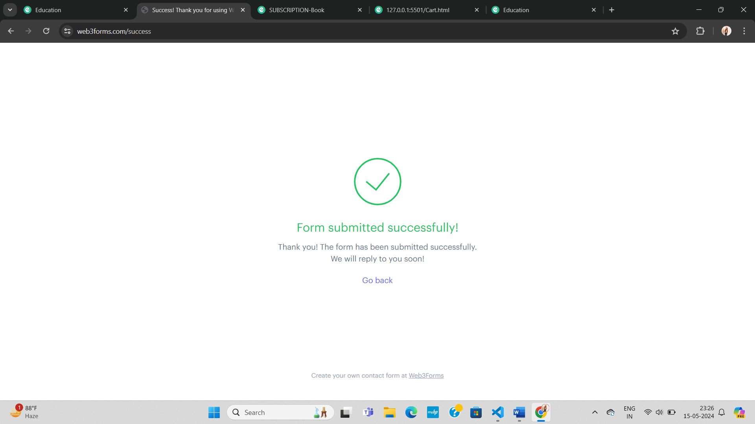

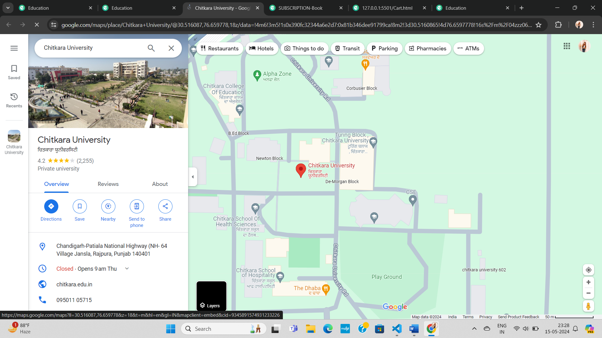

**ChatBox**

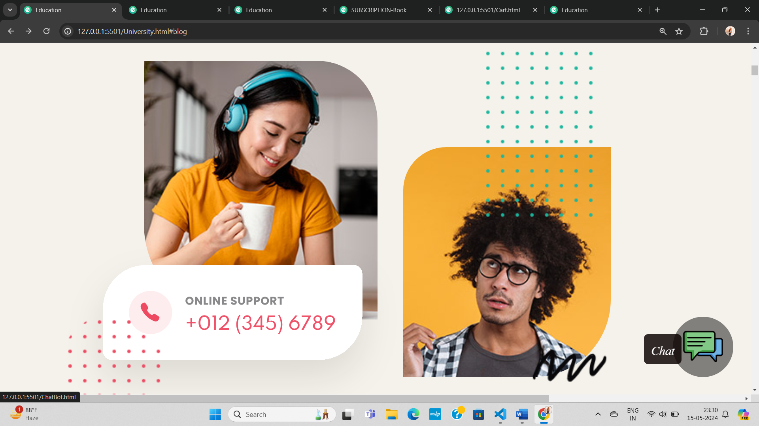

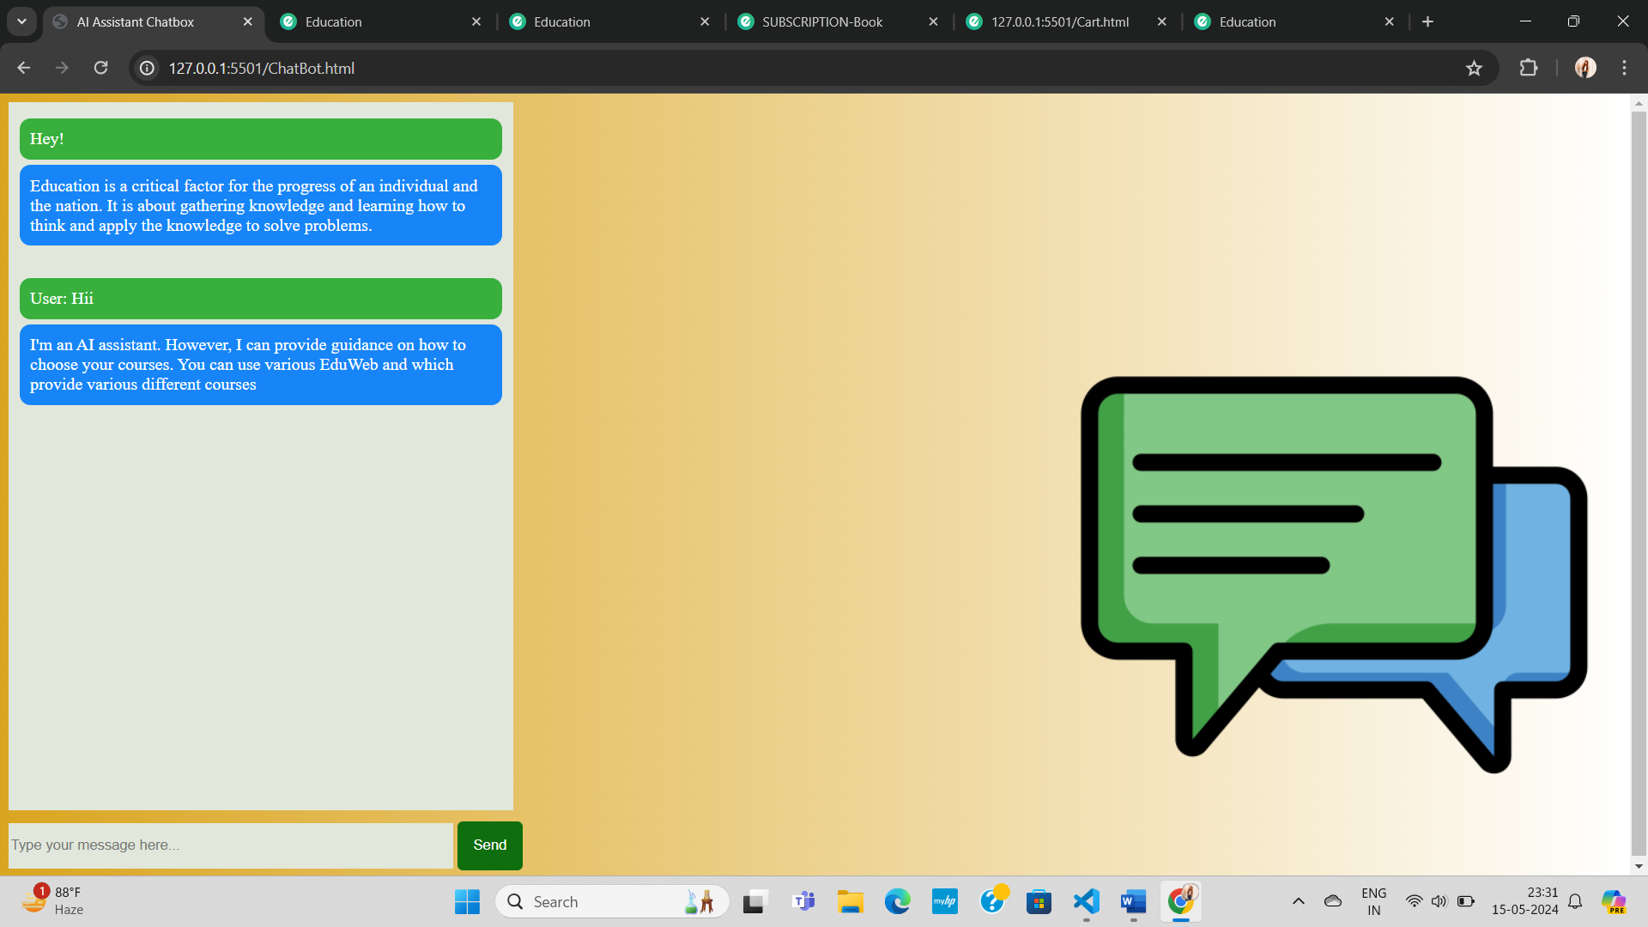

### **Educational Website References:**

1.W3 School: <https://www.w3schools.com/w3css/default.asp>

2.Bootstrap: <https://getbootstrap.com/>

3.Mdn: <https://developer.mozilla.org/en-US/docs/Web/HTML/Element/a>